* **Task for Day 1**
* I have Created website using html and CSS, I have uploaded codes on GitHub repository and screenshots are here…

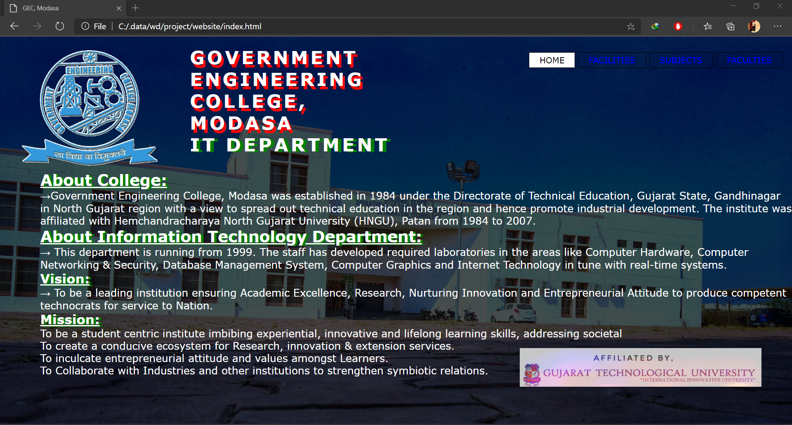**Output:**

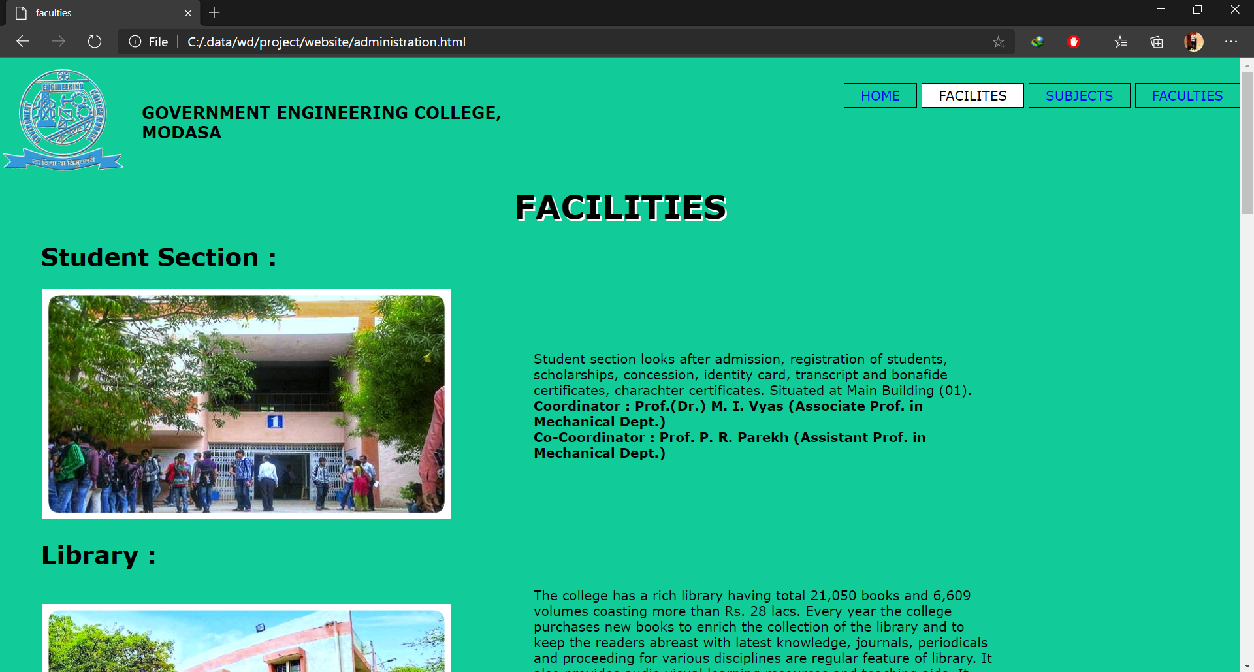 Image 1.0(homepage)

Image2.1(facilities)

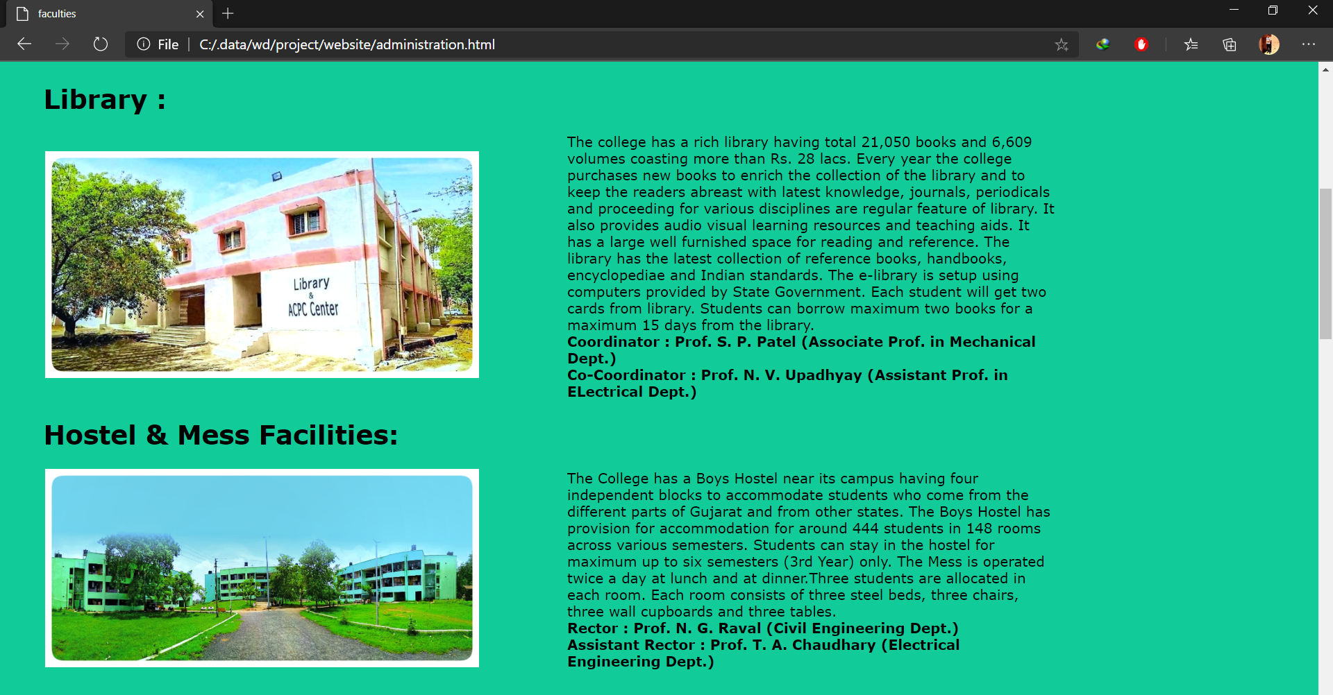

Image 2.2 (Facilities)

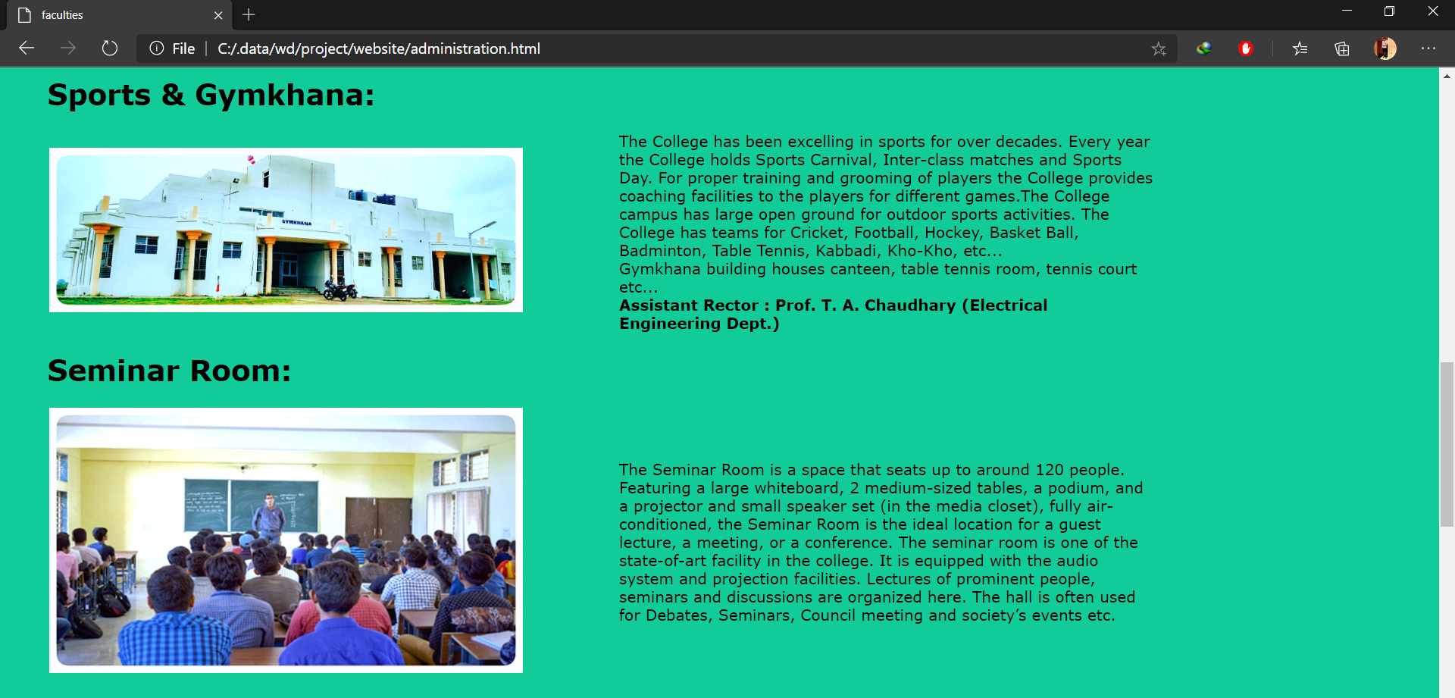

Image2.3 (Facilities)

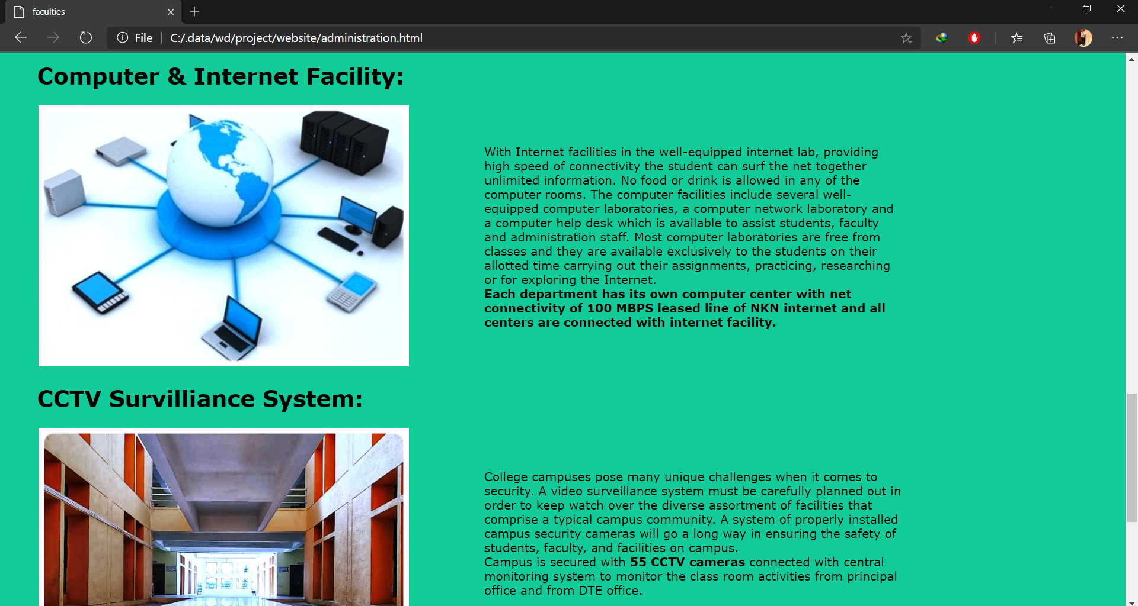

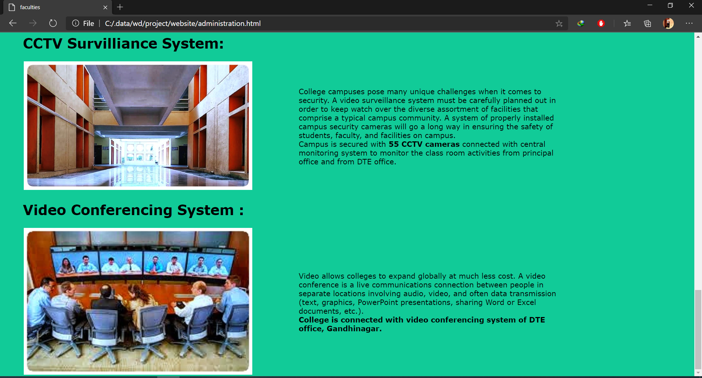 Image2.4 (Facilities)

Image 2.5 (Facilities)

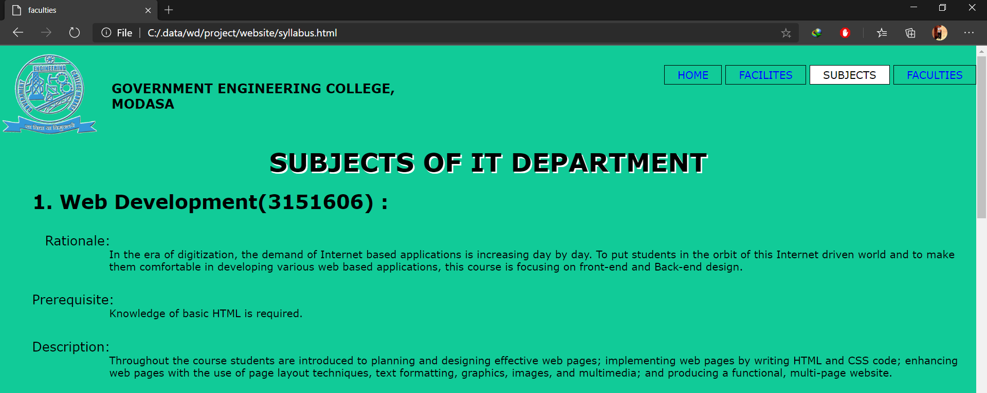

Image 3.1(subjects)

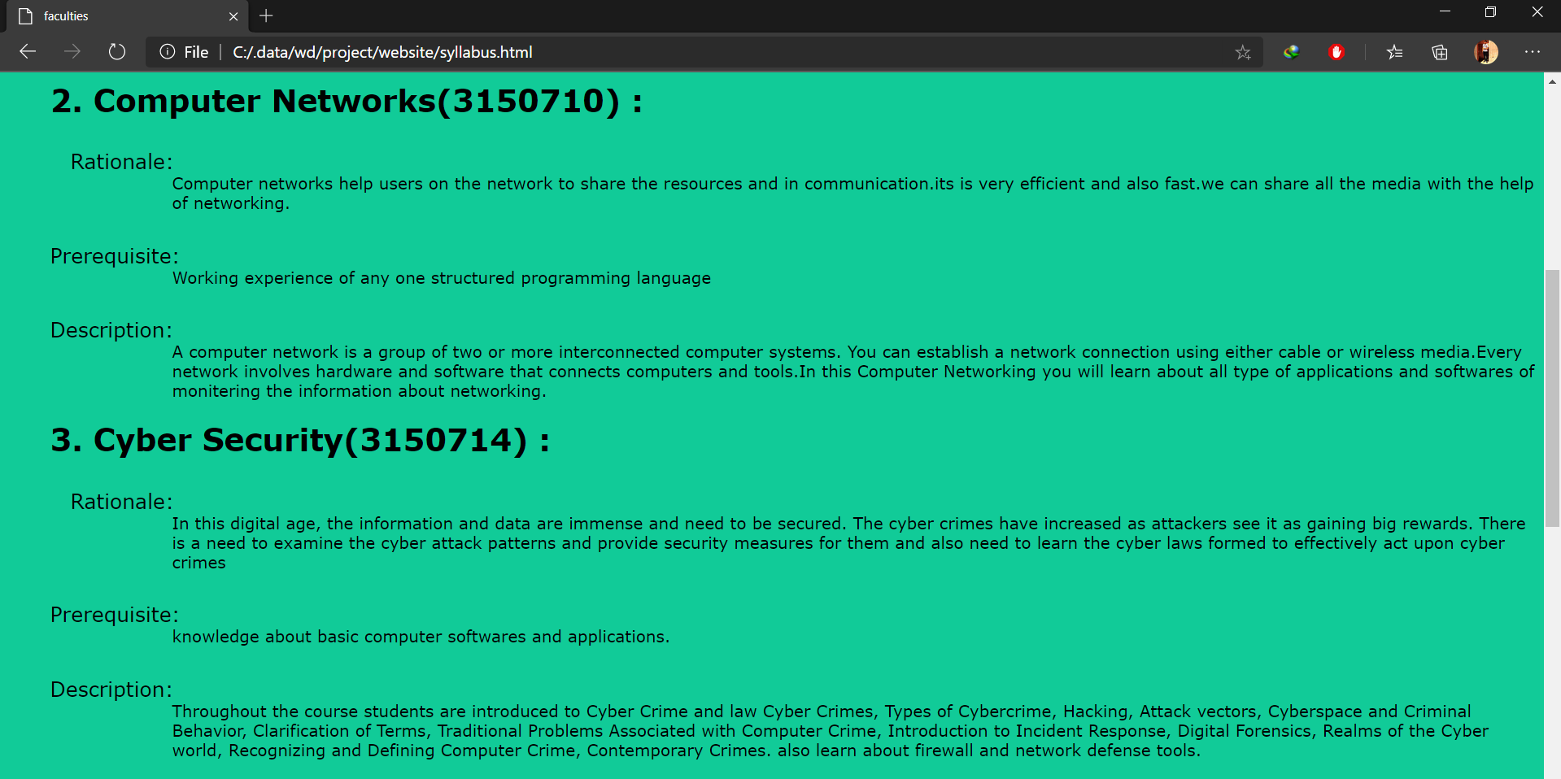

Image 3.2(Subjects)

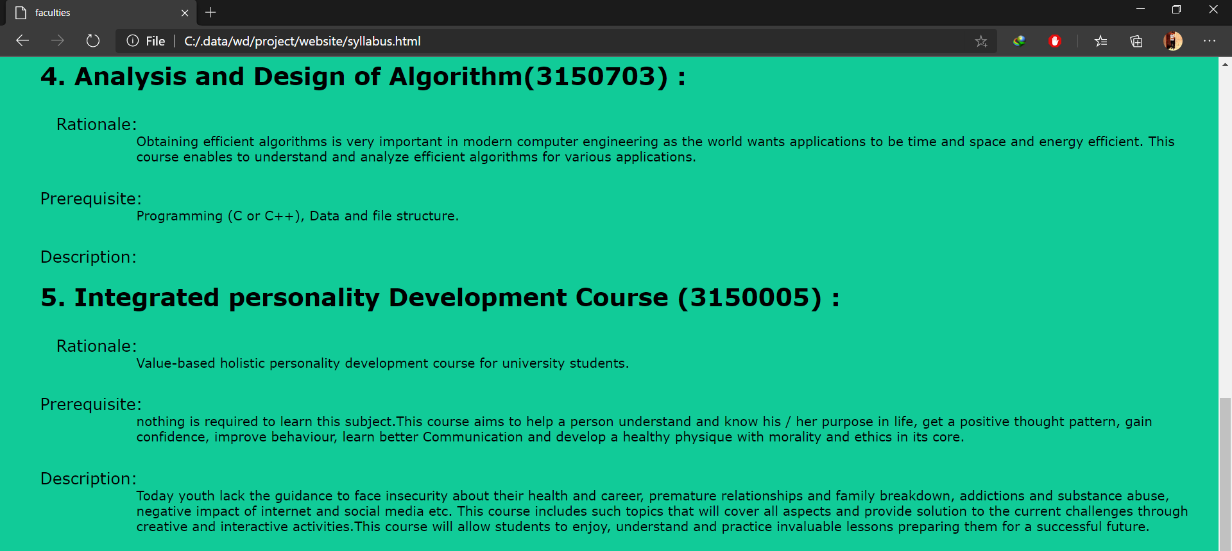

Image 3.3 (Subjects)

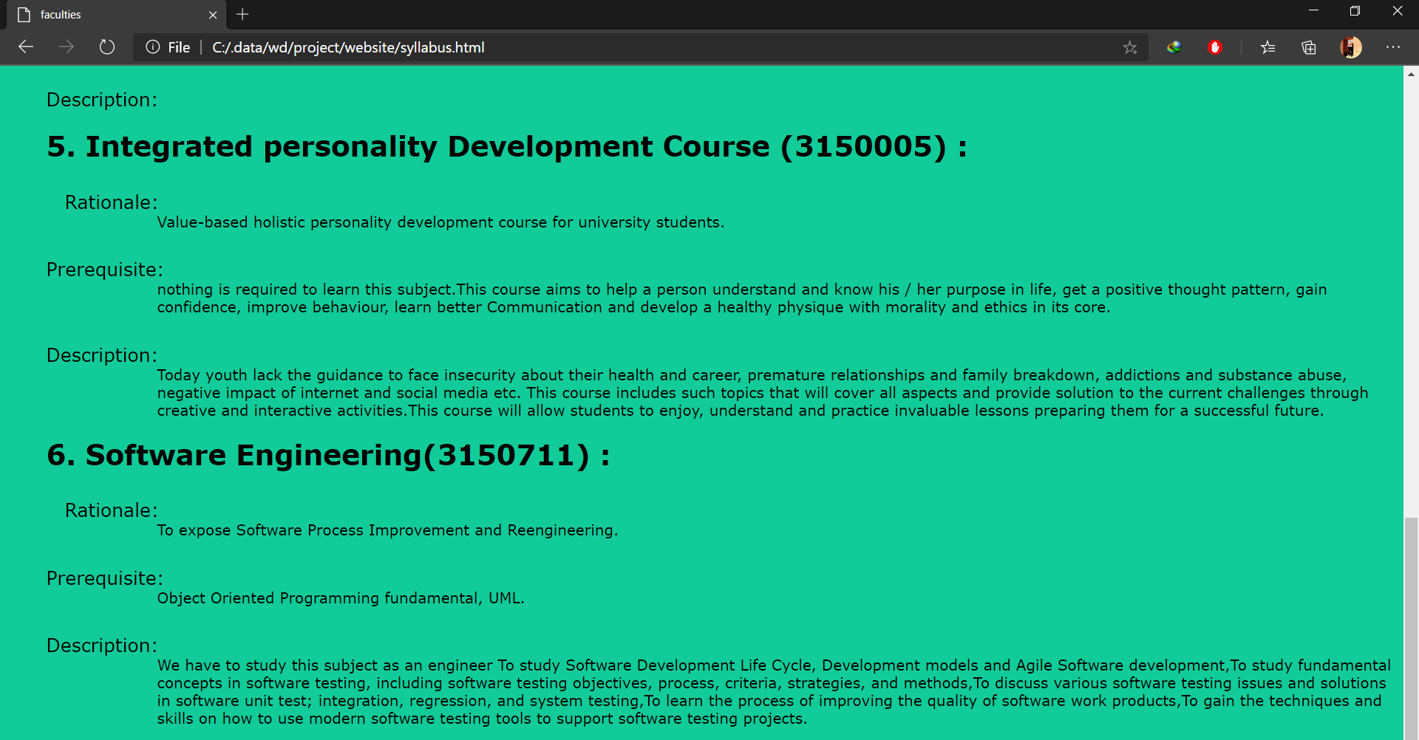

Image 3.4(Subjects)

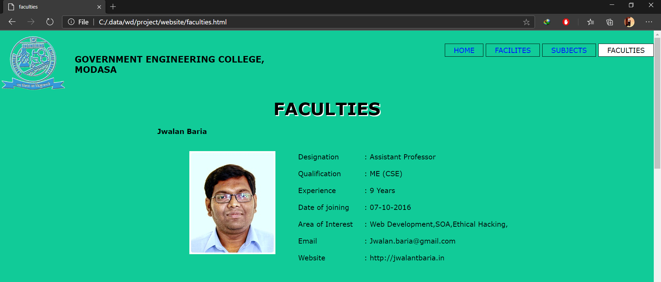

Image 4.1(Faculties)

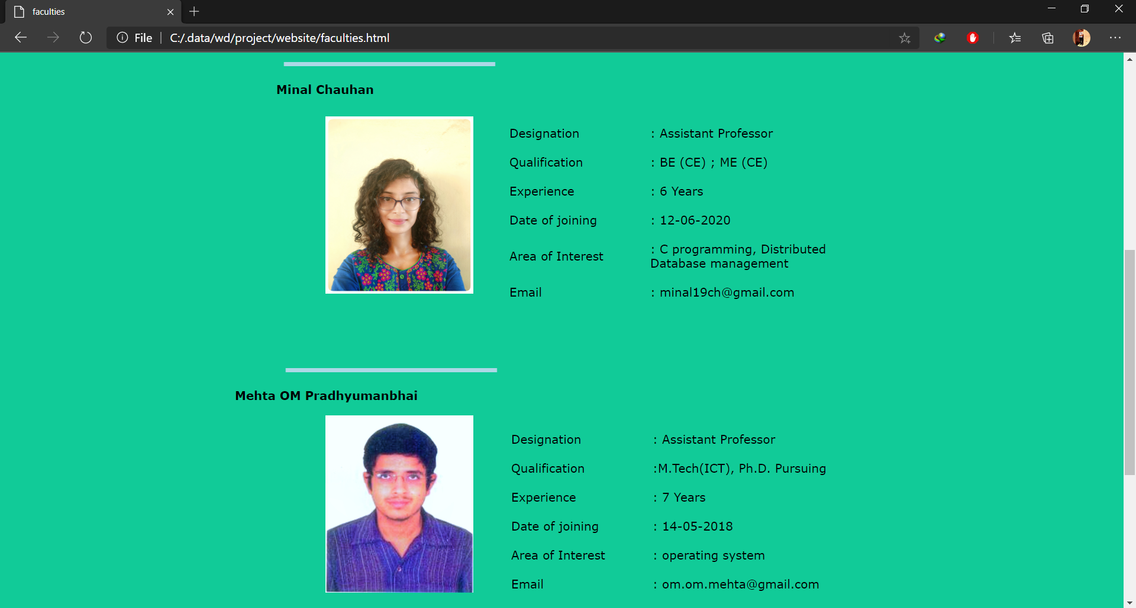

Image 4.2(Faculties)

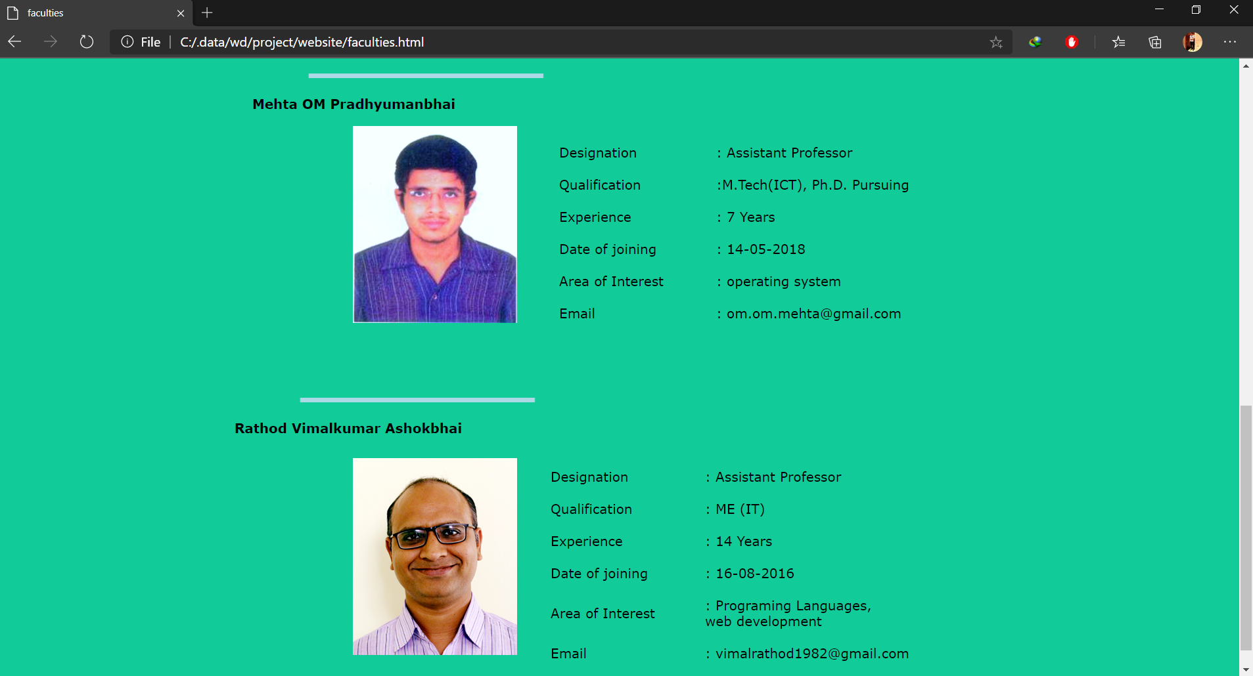

Image 4.3 (Faculties)

**Note:**

All the credit of information and photos goes to [**www.gecmodasa.ac.in**](http://www.gecmodasa.ac.in) **.**